**A Pilot Survey of Inflammatory Bowel Disease Patients on Health Insurance Satisfaction**

Authors

Amber Elder

Julajak Limsrivilai

Peter D.R. Higgins

**Background**

Patients with chronic diseases, including Inflammatory Bowel DIsease (IBD), often have difficulty with obtaining and maintaining adequate health insurance in the multipayer US health insurance market. When IBD patients shop for health insurance (generally each autumn), there is remarkably little data on customer satisfaction, health insurance ratings, or even what is covered at different levels of monthly payment and annual deductible. IBD patients are not informed consumers, and often find themselves regretting their insurance purchase decisions, which are locked in for one year.

Unfortunately, switching insurers is also problematic, as insurers use multiple policies to limit benefits, especially drug benefits for expensive biologic medications, to new policyholders and their families. This often results in gaps in coverage, and gaps in maintenance of use of biologic therapies. This is particularly problematic, as unlike small molecule therapies, gaps in biologic use can lead to increased rates of antibody formation, and loss of response to a biologic medication. Since many IBD patients are diagnosed before age 30, and often live 50 years or more with IBD, they can “burn through” the limited number of biologic medications available rather quickly.

In order to obtain an accurate picture of IBD patient satisfaction with US health care insurance, we performed a pilot survey of self-reported IBD patients with a Google Forms survey. Our primary aims were to establish the feasibility and accuracy of this approach. Our secondary aims were to look at (1) patient factors that affect overall satisfaction with health insurance, (2) insurance factors that affect overall satisfaction with health insurance, and perform preliminary univariate analyses to identify promising covariates that affect overall satisfaction. Our eventual goal is to improve our initial survey with a series of small pilots, then scale this project up to a survey through CCFA Partners of their 14,000 patient cohort of IBD patients. We hope to identify insurance factors that affect overall IBD patient satisfaction with healthcare insurance in the US, after controlling for confounding patient factors. We hope that IBD patients will be able to use this information in shopping for and selecting health insurance that will best suit their needs.

Methods

Using a Google Forms survey (see below) and posts on Twitter, we recruited a convenience sample of self-identified IBD patients following Amber Elder (@ColitisNinja) or Peter Higgins (@ibddoctor) on Twitter. Patient demographics were collected and reported as percentages, means, or medians (if skewness > 2x the standard error of the skewness). Surveys response were collected between 5/30/2015 and 6/12/2015.

The age of the respondent was derived from the survey response date and the reported date of birth. Several dichotomous variables were derived from the survey after data collection. These included the dichotomous variable ***bcbs***, for whether the patient had a version of Blue Cross/Blue Shield insurance, including Anthem; ***highdeductible***, for patients with a deductible above the median of $1000; disabled, for patients who responded disabled to the work status question; and ***everbiol***, for patients who reported that they had been on a biologic at some point in time in Q21.

Four variables were considered outcome variables: overall satisfaction with health insurance, difficulty obtaining coverage for medications, difficulty obtaining coverage for biologic therapies, and difficulty obtaining coverage for Vedolizumab. Univariate analyses of patient and insurance predictors of these outcomes were analyzed with chi square (categorical variables) or t-test (continuous variables) statistics. For continuous variables with significant skewness, the Mann-Whitney U test was used. Data were exported from Google Forms as a csv file, and were analyzed in R 3.1.2.

The survey, version 1.0:

# **Health Insurance Poll**

I recently had a discussion with Dr. Peter Higgins on Twitter about some of my friends having trouble getting the proper medications. During the course of the exchange, we decided to come up with a poll and find out how well people with IBD are getting along with their insurance companies. We hope to be able to use the information to help improve the patient's experience with healthcare. PLEASE NOTE: ALL OF YOUR ANSWERS SHALL REMAIN ANONYMOUS. THE PURPOSE OF THIS POLL IS TO GAIN INFORMATION ONLY!

* Required

* 1.Which form of IBD have you been diagnosed with? *
* Please check one.
  + Crohn's Disease
  + Ulcerative Colitis
  + Indeterminate Colitis

2. How many health insurances do you currently have?

* 3.Who is your current health insurance plan with?
* Please choose the main one.
  + Humana Group
  + UnitedHealth Group
  + Anthem Group (formerly Wellpoint, Inc. Group)
  + Aetna Group
  + Celtic
  + Assurant
  + Select Health
  + Kaiser Foundation Group
  + Cigna Health Group
  + Coventry
  + HCSC Group
  + Highmark Group
  + Blue Shield of California Group
  + Independence Blue Cross Group
  + Centene Corp Group
  + HIP Insurance Group
  + BCBS of New Jersey Group
  + BCBS of Michigan Group
  + Guidewell Mutual Holdings Group
  + California Physician's Group
  + Wellcare Group
  + Carefirst Inc. Group
  + Health Net of California Group
  + Molina Healthcare Group
  + UHC of California
  + Lifetime Healthcare Group
  + BCBS of Massachusetts Group
  + Metropolitan Group
  + Cambia Health Solutions Group
  + None of these. My health coverage is handled through a health share based company.
  + Other:

Please choose your other insurances

(same insurance choices as above)

4. How many times in the last 2 years that you have changed insurance?

5. How long have you used your current insurer?

6. If you have used your current insurance for less than 1 year, please specify your previous insurance company.

(same insurance choices as above)

* 7. Are you the policy holder of your health insurance? *
  + Yes, I am.
  + No, I am not.
  + I'm not sure.
* 8.How many people are covered under your current health insurance?
* (How many people in your household are covered? Include spouse/partner and children.)
* 9.What is your monthly insurance payment?
* Example: If your monthly payment is $200 dollars, type in, "$200".
* This includes both your own payment and your employer payment
* If the amount is in range, please input the maximum value
* € I don’t know
* 10.What is your estimated annual deductible? (deductible = a specified amount of money that you must pay before an insurance company will pay a claim.)
* Example: If your deductible is $1500 dollars, type in "$1500".
* If the amount is in range, please input the maximum value.
* Input “0” if you have no deductible.
* € I don’t know
* 11.Approximately how much out-of-pocket was spent last year? (out-of-pocket = money you have to pay adding on the insurance company pay, and not include deductible)
* Give your best estimation of how much you spent last year.
* If the amount is in range, please input the maximum value.
* Input “0” if you don’t have to pay more from the bill covered by insurance company.
* 12. How many times have you had surgery in the past year?
* Please give your best estimation.
* 13. How many times were you treated at an ER in the past year?
* Please give your best estimation.
* 14. How many times have you been hospitalized in the past year?
* Please give your best estimation.
* 15. How many endoscopies and colonoscopies total have you had in the past year?
* Please give your best estimation.
* Count the total number of procedures. For example, if you underwent both upper endoscopy and colonoscopy within the same session, please count as 2 procedures.
* 16. What strategies have you seen insurance companies use to make it more difficult to get medications paid for?
* 17. Does your insurance company cover biologic medications (e.g., Remicade, Simponi, Cimzia, Entyvio, Humira)? *
  + Yes
  + No
  + Not Applicable
* 18.If you answered "No," please explain your experience.
* 19.Does your insurance forced switch of your biologic medications?
  + Yes
  + No

20. If yes, which biologics your insurance company preferred? (can select > 1 choice)

* + Remicade
  + Humira
  + Cimzia
  + Simponi
  + Entyvio

21.Did you use a company assistance program/copay program?

* + Yes
  + No
* 22.Has your insurance company denied payment for other medications that your physician has prescribed? *
  + Yes
  + No
* 23. What tips or tricks can you share with other people living with IBD who need help in working with insurance carriers to receive benefits?
* Your answer could help future patients get the help and medications that they need.
* 24.How would you rate the overall service of your insurance company for IBD patients?
* If not applicable, please skip to next question.

|  |  |  |  |  |  |  |  |  |  |  |  |
| --- | --- | --- | --- | --- | --- | --- | --- | --- | --- | --- | --- |
|  |  | * 2 | * 3 | * 4 | * 5 | * 6 | * 7 | * 8 | * 9 | * 10 |  |
| * Bad |  |  |  |  |  |  |  |  |  |  | * Great |

* 25.Please rate your difficulty getting IBD medications covered.
* If not applicable, please skip to next question.

|  |  |  |  |  |  |  |  |  |  |  |  |
| --- | --- | --- | --- | --- | --- | --- | --- | --- | --- | --- | --- |
|  | * 1 | * 2 | * 3 | * 4 | * 5 | * 6 | * 7 | * 8 | * 9 | * 10 |  |
| * Extremely Easy |  |  |  |  |  |  |  |  |  |  | * Extremely Difficult |

* 26. Please rate your difficulty getting anti-TNF biologics covered.
* If not applicable, please skip to next question.

|  |  |  |  |  |  |  |  |  |  |  |  |
| --- | --- | --- | --- | --- | --- | --- | --- | --- | --- | --- | --- |
|  | * 1 | * 2 | * 3 | * 4 | * 5 | * 6 | * 7 | * 8 | * 9 | * 10 |  |
| * Extremely Easy |  |  |  |  |  |  |  |  |  |  | * Extremely Difficult |

* 27. Please rate your difficulty getting Entyvio covered.
* If not applicable, please skip to next question.

|  |  |  |  |  |  |  |  |  |  |  |  |
| --- | --- | --- | --- | --- | --- | --- | --- | --- | --- | --- | --- |
|  | * 1 | * 2 | * 3 | * 4 | * 5 | * 6 | * 7 | * 8 | * 9 | * 10 |  |
| * Extremely Easy |  |  |  |  |  |  |  |  |  |  | * Extremely Difficult |

* 28. Would you recommend this type of health insurance to other IBD patients?
  + Yes
  + No
* 29. If you have ever been on a biologic, have you ever had a gap in your treatment because of insurance?
  + Yes
  + No
  + Not sure
  + Not Relevant (I have never been on a biologic)

30. If your answer to the question No.29 is “yes”, how long was the gap?

___________ months ___________weeks

31. If your answer to the question No.29 is “yes”, which biologic did you have a gap for?

* 32. If your answer to the question No. 29 is "yes," please explain why:
* Check all that apply.
  + denial (after previous approval)
  + slow approval/prior authorization
  + slow or no annual renewal
  + gap when I changed insurance companies
  + Other:
* 33. If you checked "other," please explain.
* 34.Did you develop antibodies to the biologic because this gap in your medication coverage?
  + Yes
  + No
  + Not Applicable

35. Before or during the gap were you on an immunomodulator like Imuran or methotrexate?

* + Yes
  + No
  + :
* 36. Would you be interested in viewing the results from this poll?
  + Yes
  + No
* 37. What is your average yearly household income?
  + Less than $25,000
  + $25,000 - $34,000
  + $35,000 - $49,999
  + $50,000 - $79,999
  + $80,000 - $100,000
  + Over $100,000
* 38. If you are under 26 years of age, are you on your parents' insurance plan?
* Please choose one.
* Yes No
* Please choose one of the following:
  + currently working
  + not working by choice
  + disabled
  + unable to find work
* 39. What state do you live in?
* Alabama Alaska Arizona Arkansas California Colorado Connecticut Delaware Florida Georgia Hawaii Idaho Illinois Indiana Iowa Kansas Kentucky Louisiana Maine Maryland Massachusetts Michigan Minnesota Mississippi Missouri Montana Nebraska Nevada New Hampshire New Jersey New Mexico New York North Carolina North Dakota Ohio Oklahoma Oregon Pennsylvania Rhode Island South Carolina South Dakota Tennessee Texas Utah Vermont Virginia Washington West Virginia Wisconsin Wyoming

|  |
| --- |
|  |

Results

*Respondent Characteristics*

The sample of 48 respondent included 23 with self-reported Crohn’s disease, 21 with ulcerative colitis, and 4 with indeterminate colitis. Respondents from 24 states were represented, with the most frequent being California and Ohio (4), followed by Illinois, North Carolina, Pennsylvania, and Washington (3).The average age of respondents was 35.82. In terms of gender, 77.1% were female. In terms of race, 93.8% were white, with 2.1% black. In terms of household income, the most common income brackets were $50,000-79,999 and >$100,000 per year, both with 29.2%. Eighteen patients reported that they were under 26, and 50% of these were on their parents’ insurance. Two-thirds of respondents are currently working, 16% disabled, and 12.5% not working by choice. Of the 48 respondents, 39 (81.25%) have been on a biologic at some point in their lives. The respondents averaged 1.8 ER visits, 1.28 hospitalizations, and 0.8 surgeries per year.

*Insurer Characteristics*

Twenty-eight different insurers were represented, with the most common being Aetna(4), Anthem BCBS (3), BCBS of Illinois(3), Highmark (3), and United Health Group (3). Of the insurers, 47.9% were some form of BlueCross coverage, and 43.8% had deductibles greater than $1000. Among respondents, 70.8% were the policyholder, with an average of 2.23 people covered. Of the respondents, 43.75% reported that their health insurer had denied payment for a medication that their physician had prescribed for IBD. All 39 respondents to whom it was relevant reported that their health insurer covered biologics; for 9 this was not applicable. On a 1 (easy) - 10 (difficult) scale, respondents rated the difficulty of getting medications covered for IBD (mean 3.9), difficulty of getting anti-TNF biologics covered (mean 5.1), and difficulty of getting Entyvio covered (mean 4.6). Thirteen patients (27.1%) have experienced a gap in biologic therapy due to insurance problems. Of these, 7/13 were due to slow approval processes, 3 after a change in health insurance, 2 annual denials after previous approval, 1 due to denial of the particular dose, and 1 due to miscommunication with a pharmacy. Of these thirteen, 3 developed antibodies to the biologic therapy due to the gap in therapy. The average monthly insurance payment was $329.80, the average deductible was $1772, and the average annual out of pocket spend was $3636. Ninety-seven percent of IBD patients had out of pocket health care expenditures that exceeded their deductible. Overall satisfaction with service provided by their healthcare insurance on a 1-10 scale averaged a 7.13 (SD 2.18).

|  |  |  |  |
| --- | --- | --- | --- |
| Characteristic | Percent | Mean(SD) | Median(IQR) (min-max) |
| Crohn’s Disease/ Ulcerative Colitis/ Indeterminate Colitis | 47.9  43.8  8.3 |  |  |
| Age |  | 35.82 (10.19) | 34.39 (27.6-39.1) |
| Gender  Male  Female | 20.9  77.1 |  |  |
| Race  White  Black  Refused to Answer | 93.8  2.1  4.2 |  |  |
| Ethnicity  Hispanic or Latino  Other  Refused to Answer | 4.2  81.3  14.6 |  |  |
| Income Category  <$25,000  $25,000-34,999  $35,000-49,999  $50,000-79,999  $80,000-100,000  > $100,000  Refused to Answer | 8.3  8.3  8.3  29.2  14.6  29.2  2.1 |  |  |
| If <26, on parents’ insurance  Yes  No | 50  50 |  |  |
| Work Status  Working  Disabled  Not working by choice  Refused to Answer | 66.7  16.7  12.5  4.2 |  |  |
| Number of ER visits |  | 1.826 (2.56) | 1 (0-2.75)  (0-12) |
| Number of Hospitalizations |  | 1.283 (1.80) | 1 (0-1.75)  (0-6) |
| Number of Surgeries |  | 0.8043 (1.31) | 0 (0-1)  (0-5) |
| **Health Insurance** Policyholder  Yes  No | 70.8  29.2 |  |  |
| Number of people covered |  | 2.277 (1.25) | 2 (1-3)  (1-5) |
| Denied Payment for Medications  Yes  No | 43.8  56.2 |  |  |
| Difficulty of IBD Medication Coverage (1-10) |  | 3.891 (2.68) | 3 (1.25-6)  (1-10) |
| Difficulty of anti-TNF Coverage (1-10) |  | 5.135 (3.04) | 5 (3-7)  (1-10) |
| Difficulty of Entyvio Coverage (1-10) |  | 4.6 (3.204) | 4 (2.5-5)  (1-10) |
| Gap in Biologic Therapy Due to Insurance  Yes  No  Not Relevant  Not Sure | 27.1  45.8  18.8  8.3 |  |  |
| Why Gap Occurred  Slow Approval  Change in Insurance  Annual renewal denied  Pharmacy Problem | 7 (50%)  3 (21%)  3 (21%)  1 (7%) |  |  |
| Antibodies to Biologic Due to Gap in Coverage  Yes  No | 3 (21%)  11 (79%) |  |  |
| Monthly Payment |  | 329.80 (286.99) | 300 (142.5-400)  (0-1400) |
| Annual Deductible |  | 1772 (1872.86) | 1000 (500-3000)  (0-6500) |
| Annual Out of Pocket Spent on Healthcare |  | 3636 (4010.99) | 2500 (1000-5000)  (0-20,000) |
| Overall Satisfaction with Health Insurance |  | 7.13 (2.18) | 8 (6-9)  (1-10) |

*Patient Predictors of Overall Satisfaction*

Eleven patient characteristics were tested for their association with overall satisfaction with health insurance in bivariate models. The estimates of effect and P values are listed below. Only disabled status was significant, with a strong negative effect on overall satisfaction. Trending positively were the number of hospitalizations and high income, which were weakly associated (NS) with increased satisfaction.

|  |  |  |
| --- | --- | --- |
| Predictor | Estimate | p value |
| IBD type (vs. CD)  Ulcerative colitis  Indeterminate colitis | 0  0.9239  0.5423 | 0.443  0.431 |
| Age (per year) | 0.0195 | 0.768 |
| Gender (vs. female)  Male | 0  0.4722 | 0.550 |
| Race (vs. black)  White | 0  -2.932 | 0.191 |
| Ethnicity (vs. Not Hispanic)  Hispanic or Latino | -0.500 | 0.784 |
| Income >$80,000 | 0.9867 | 0.127 |
| Disabled status | -2.5789 | 0.00153 |
| Number of ER visits | 0.1350 | 0.277 |
| Number of Hospitalizations | 0.2968 | 0.0901 |
| Number of Surgeries | 0.1799 | 0.462 |

*Insurance Predictors of Overall Satisfaction*

Thirteen insurance characteristics were tested for their association with overall satisfaction with health insurance in bivariate models. The estimates of effect and P values are listed below. “Denied payment for a medication in the past year”, “Coverage difficulty for any IBD medications”, “Coverage difficulty for anti-TNF therapy” and presence of “Gap in biologic therapy” were significant, with a strong negative effect on overall satisfaction. Trending positively was the coverage by Blue Cross insurance, which was weakly associated (NS) with increased satisfaction.

|  |  |  |
| --- | --- | --- |
| Predictor | Estimate | p value |
| Blue Cross vs.  Not Blue Cross | 1.0435 | 0.105 |
| Monthly Payment | 0.01 | 0.965 |
| Annual Deductible | -0.01 | 0.517 |
| High Deductible | -0.6706 | 0.309 |
| Out of pocket spend | -0.01 | 0.289 |
| Policyholder | -0.1399 | 0.847 |
| Number of persons covered | -0.1627 | 0.551 |
| Denied Payment for a Medication in the Past Year | -2.4423 | <0.0001 |
| Coverage for Biologics | -0.2961 | 0.731 |
| Coverage Difficulty for any IBD medication | -0.3713 | 0.00216 |
| Coverage Difficulty for anti-TNF therapy | -0.2668 | 0.0215 |
| Coverage Difficulty for Entyvio | -0.4719 | 0.131 |
| Gap in Biologic Therapy | -1.2817 | 0.0683 |

*Graphs of potentially important Covariates for Overall Satisfaction*

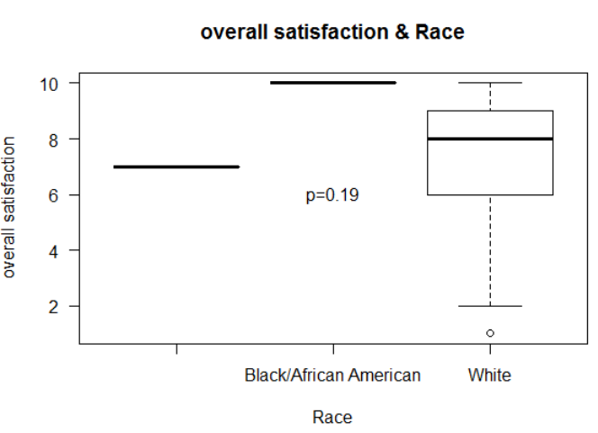

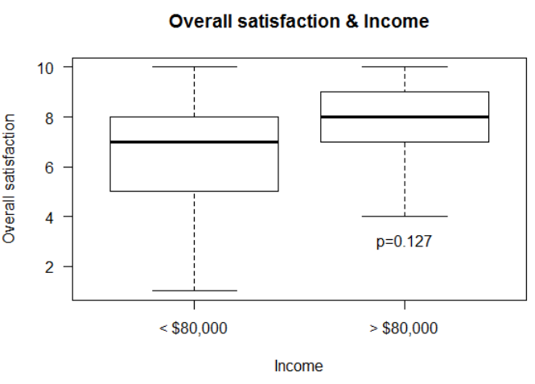

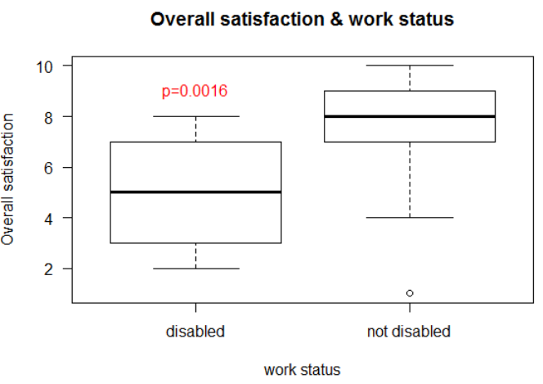

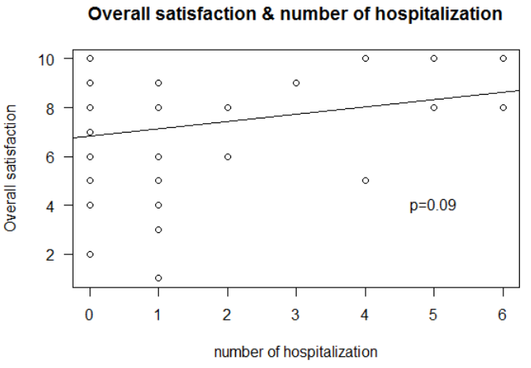

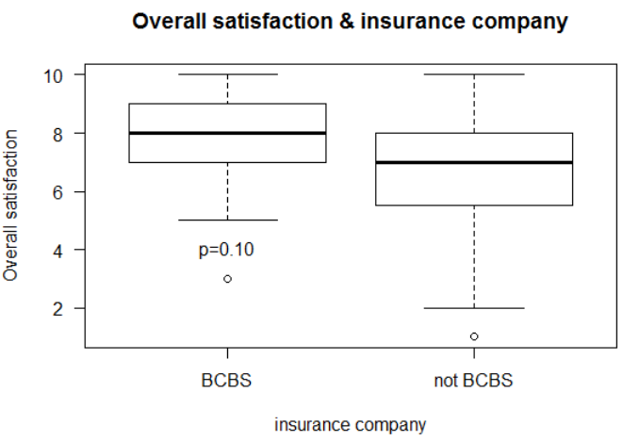

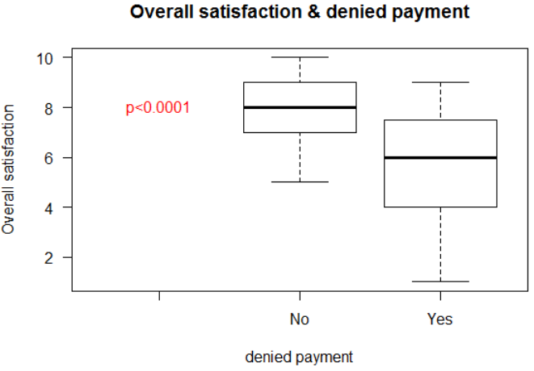

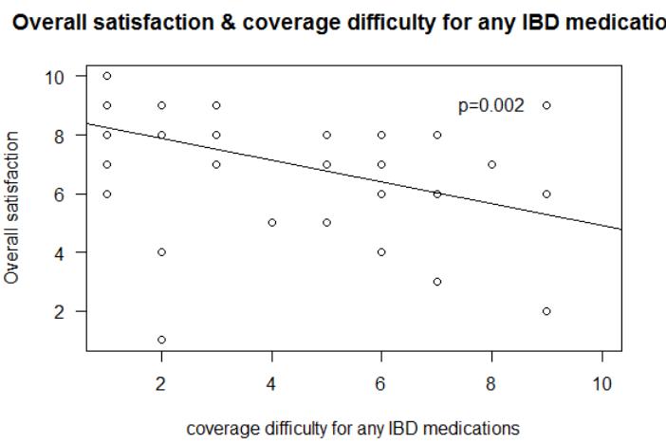

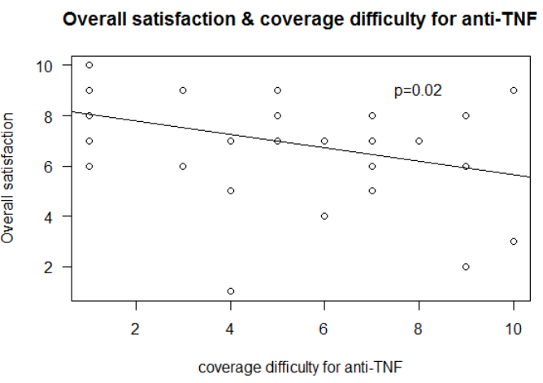

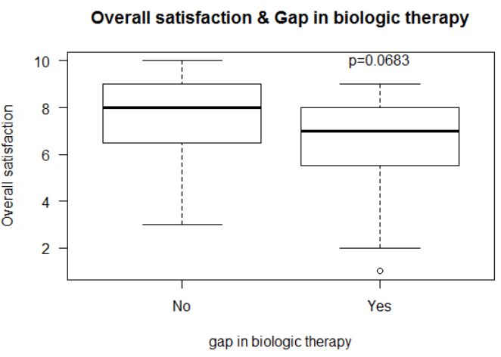

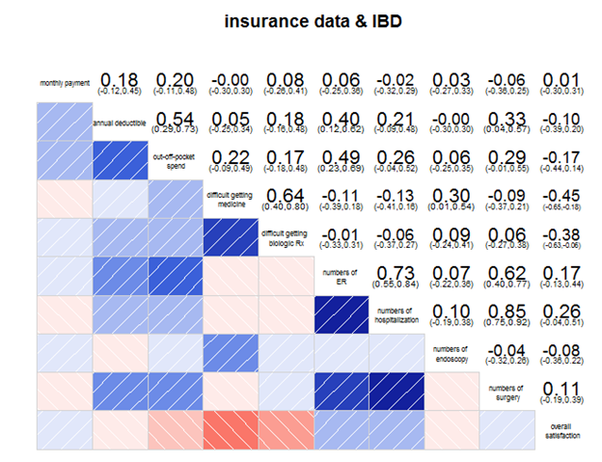

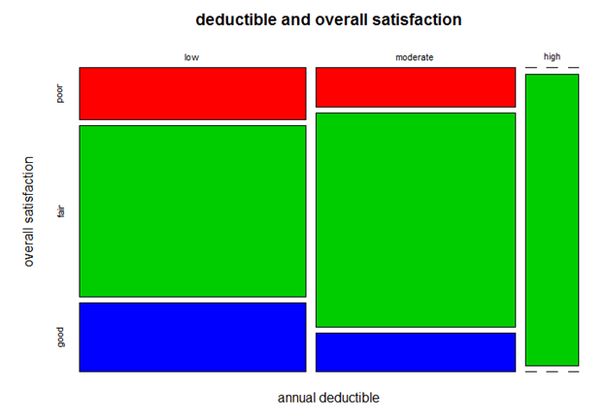

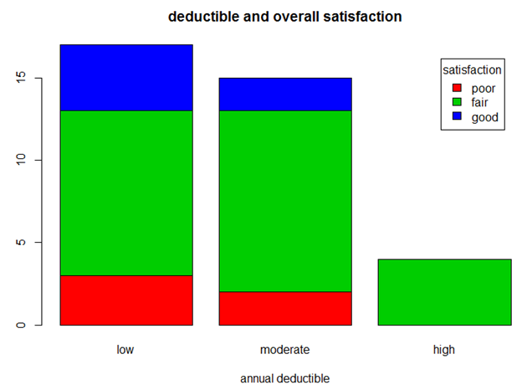

Overall satisfaction

- 0-4 = poor

- 5-8 = fair

- 9-10 = good

Annual deductible

- 0-1000 = low

- 1001-5000 = moderate

- 5001-10000 = high

*Data Issues*

* There was enormous variation in inputting the name of insurance company. Many insurance companies were identified by different names (i.e. Blue Cross/Blue Shield of Illinois as “BCBSIL”, BlueCross IL”, Blue cross Illinois”)
* There was significant variation in inputting the data associated with cost such as “income”, “deductible”, “out-of-pocket” as follows;
  + input in separate categories, for example “$200, employer $380” → should note your contribution. Question should be clearer.
  + input as a range, for example “$2500-$5000” → should note “maximal value”
  + input as “don’t know or I don’t know” → should note “leave it blank if you don’t know” - should have a selection for IDK
  + input as “no deductible” → should note “input 0 if you have no deductible”
  + Need to have clearer explanation of deductible - some patients did not understand.
  + Need to have clearer explanation of out of pocket spending - some patients included deductible, some did not.
* For “number of endoscopy”, some patients answered “one per each”
* Some had more than one insurance
* “Race is a social construct” response
* “Gender norming is oppression” response
* You could also ask if the insurance company has preferred biologics. Mine does. I have to use Humira and Remicade before they'll pay for anything else. Even if my doc wants me on something else like Cimzia.

*Additional Potential Questions*

1. How to capture all possible insurers - certainly BCBS by state, but many options - how to include all reasonable options? VA, Tricare, etc. - perhaps a branching question - state first, then a pick list of all health insurers for that state
2. Ask about pharma programs for copay assistance - does that affect satisfaction?
3. Make sure patients understand what is meant by deductible, out of pocket, etc.
4. Any information on forced switch of biologics by insurers?
5. Data on how long with current insurer?
6. Data on how many times in the last N years that they have changed insurance?
7. If they could get lower rates, or free preventive care, would they sign up for longer than 1 year with an insurer? How much lower would they have to be/how much benefit?
8. Add "Would you recommend this type of health insurance to other IBD patients?" Yes/No
9. Clarify if you have 2 types of insurance. Focus on insurance for meds
10. specify how long you have had this insurance
11. How many times have you switched insurers
12. gender and race issues -
13. if covered by current insurer for less than one year, evaluate your previous insurer.
14. Explain deductible
15. explain out of pocket, how to calculate (include deductible or not).
16. explain monthly payment - patient part vs. employer part.
17. How long was the gap in biologic therapy?
18. Which biologic therapy did you have a gap for?
19. Before or During the gap were you on an immunomodulator like imuran or methotrexate?
20. How many times have you been prescribed a biologic, of those, how many times initially denied?
21. How long did it take to get approval from your insurance for a biologic. I've had it take a few weeks to get prior authorizations to get through
22. Did you use a company assistance program/copay program?
23. Another thing you could ask is how much each patients co-payment is for their biologic. You could ask how much it is with insurance and then how much it is after they have the manufacture's copayment card applied. Like my Humira would be $120 a month but I only pay $5 because of Abbvie's copayment card.
24. I don't know if you guys want to distinguish between PPO, HMO, ect plans. Because depending on which one you have depends on how things work with copayments, deductibles, ect.
25. You could also ask if the insurance company has preferred biologics. Mine does. I have to use Humira and Remicade before they'll pay for anything else. Even if my doc wants me on something else like Cimzia.

*Future Plans*

1. Improve questions - monthly payment - how much do you pay? separate from employer - can say dont know.
2. Explain that respondents may have to look up information like deductible, monthly payment, OOP spend. For children, ask parents?
3. Get feedback from patients
4. Add questions
5. Apply CCFA partners
6. Do N=1000 pilot with CCFAP. Test, develop clean code to analyze, revise.
7. With Final version, do N=13,000 version with CCFAP